# Paper to be studied:

|  |  |  |  |  |  |  |
| --- | --- | --- | --- | --- | --- | --- |
| *Stacking* | (1) A survey of ensemble learning: Concepts, algorithms, applications, and prospects |  |  |  |  |  |
| *ML Systematic Review* | P. K. Jain, R. Pamula, and G. Srivastava, ‘‘A systematic literature review 1799 on machine learning applications for consumer sentiment analysis using 1800 online reviews,’’ Comput. Sci. Rev., vol. 41, Aug. 2021, Art. no. 100413, 1801 doi: 10.1016/j.cosrev.2021.100413 | (1) A survey of ensemble learning: Concepts, algorithms, applications, and prospects | Classic / Supervised / Stacking | 223 | 2021 | Yes |
| *Stacking* | M. Liang, T. Chang, B. An, X. Duan, L. Du, X. Wang, J. Miao, 1765 L. Xu, X. Gao, L. Zhang, and J. Li, ‘‘A stacking ensemble learn1766 ing framework for genomic prediction,’’ Frontiers Genet., vol. 12, 1767 Mar. 2021, Art. no. 600040, Accessed: May 2, 2022. [Online]. Available: 1768 https://www.frontiersin.org/article/10.3389/fgene.2021.600040 | (1) A survey of ensemble learning: Concepts, algorithms, applications, and prospects |  |  |  |  |

# URLs

1. Paper 1: [IEEE Xplore Full-Text PDF:](https://ieeexplore.ieee.org/stamp/stamp.jsp?tp=&arnumber=9893798)
2. Tech Doc: [Stacking Ensemble Machine Learning With Python - MachineLearningMastery.com](https://machinelearningmastery.com/stacking-ensemble-machine-learning-with-python/)
3. [Essence of Stacking Ensembles for Machine Learning - MachineLearningMastery.com](https://machinelearningmastery.com/essence-of-stacking-ensembles-for-machine-learning/)
4. Has multiple algorithms we can use: [Improve your Predictive Model's Score using a Stacking Regressor - Analytics Vidhya](https://www.analyticsvidhya.com/blog/2020/12/improve-predictive-model-score-stacking-regressor/)

# Documentating the work

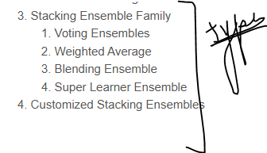

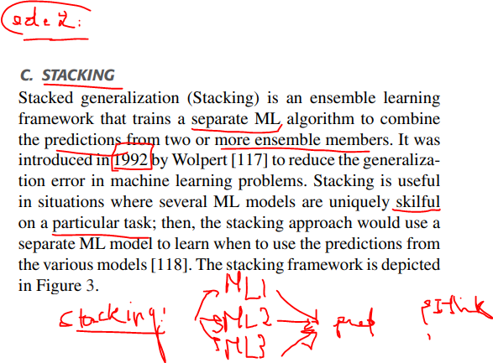

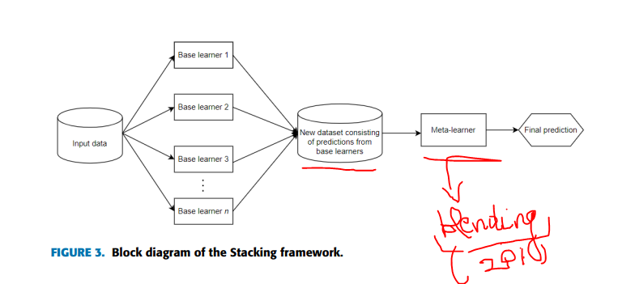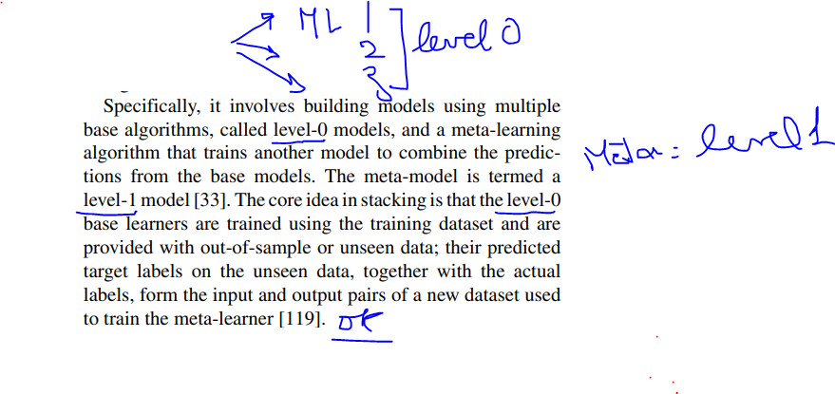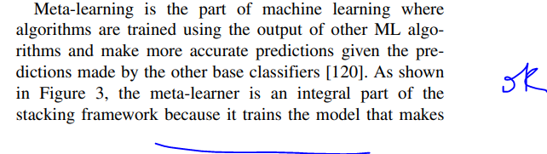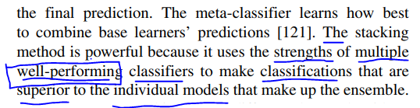

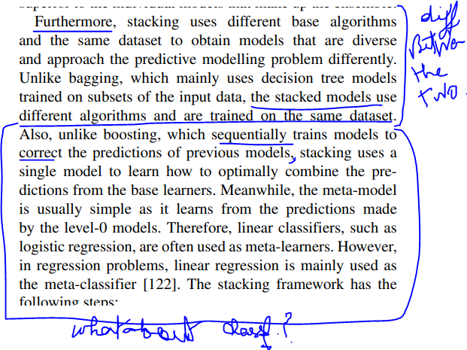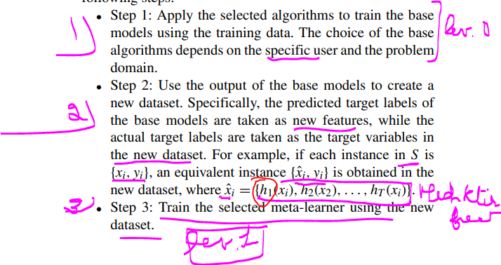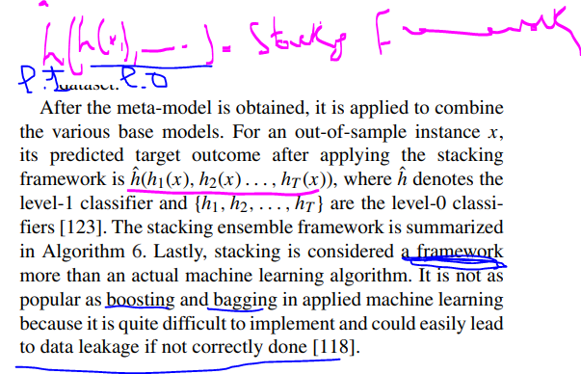

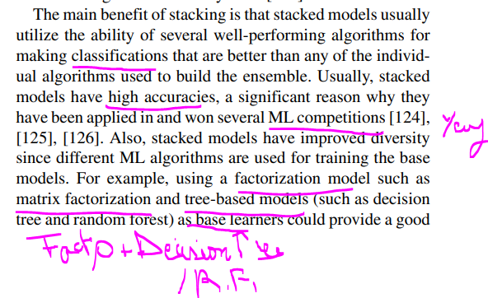

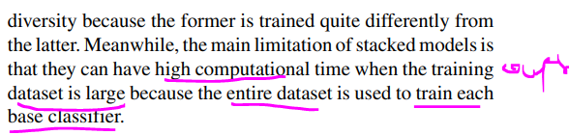

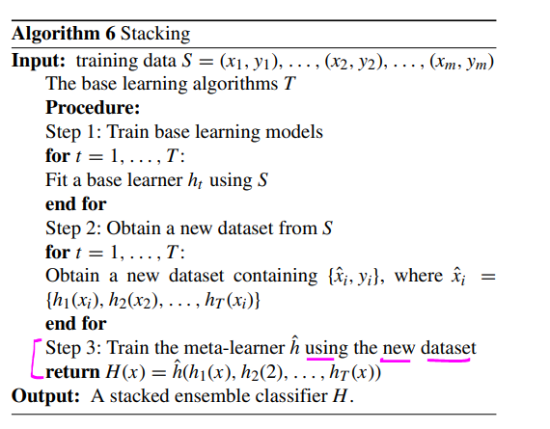

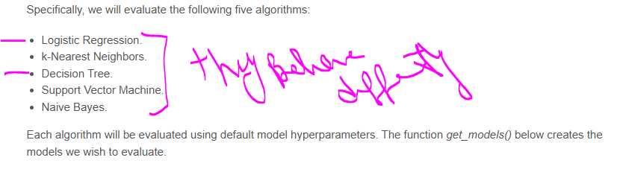1- Algorithms Test:

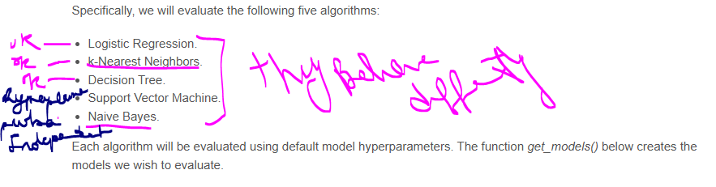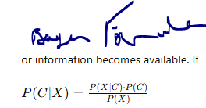

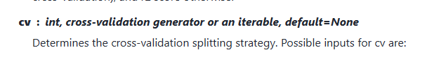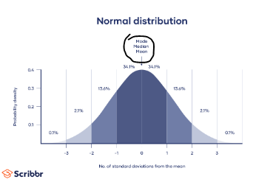

We will switch Logistic Regression with A CNN Model as LR can’t take this much input

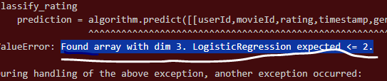

CNN: I wasnt able to add CNN

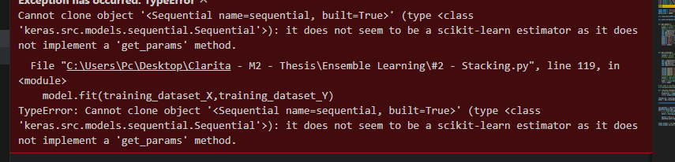KNN Failed as well:

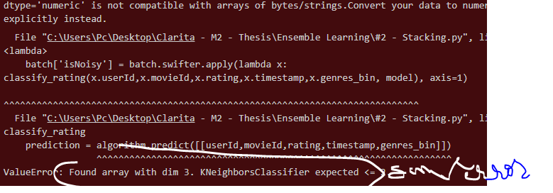

[scikit learn - dtype='numeric' is not compatible with arrays of bytes/strings.Convert your data to numeric values explicitly instead - Stack Overflow](https://stackoverflow.com/questions/74878793/dtype-numeric-is-not-compatible-with-arrays-of-bytes-strings-convert-your-data)

Said to try and make sure the datatype is dfloat -> So I added this:  
 X = np.array([userId,movieId,rating,timestamp,genres_bin], dtype=np.float64)

What should the actual input be?  
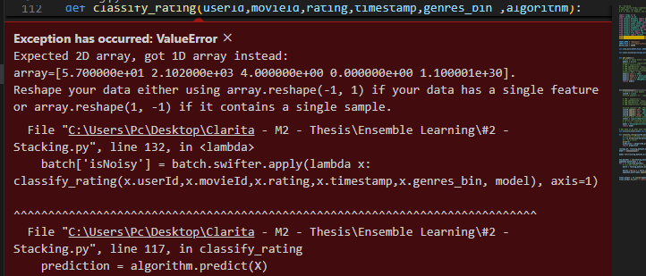

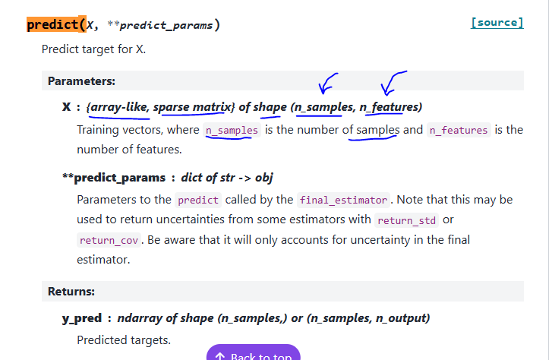

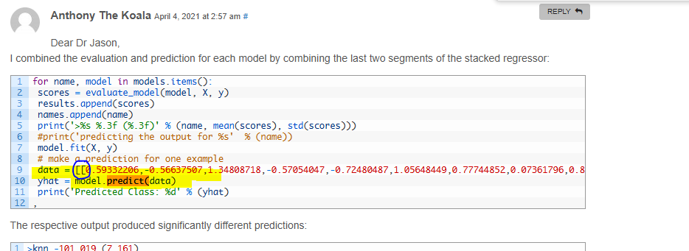

Example in a doc:

What are the models That can be used inside the Stacking Algorithm:

Option 2:

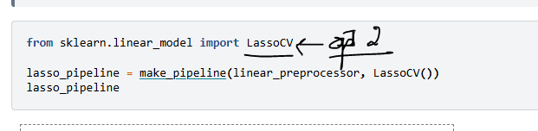Option 3:

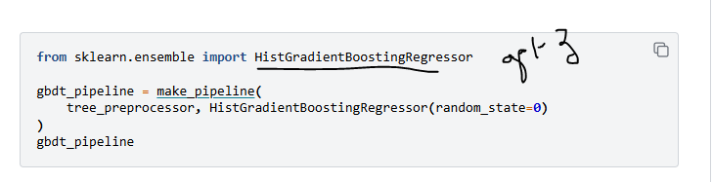

Maybe last level instead of LogisticRegression

**from** sklearn.linear_model **import** [RidgeCV](https://scikit-learn.org/stable/modules/generated/sklearn.linear_model.RidgeCV.html#sklearn.linear_model.RidgeCV)

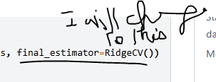

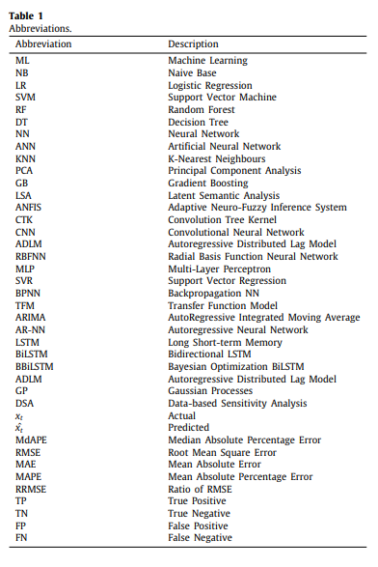

## Cons:

**Complexity:** Higher complexity in terms of model training and interpretation. Stacking can be more complex to implement than using a single machine learning model.

**Data Requirements:** Requires a sufficiently large dataset to train diverse models effectively.

**Computational cost:** Stacking can be more computationally expensive than using a single machine learning model.

**Interpretability:** Stacking can be more difficult to interpret than using a single machine learning

## Pros:

**Increased Accuracy:** Often outperforms individual models and other ensemble methods.

**Model Diversity:** Can incorporate diverse models to capture various patterns.

**Adaptability:** Can be tailored to different problem complexities and datasets.

**Improved performance:** Stacking can often be used to improve the performance of machine learning models.

**Robustness:** Stacking is more robust to overfitting than using a single machine learning model.

**Flexibility:** Stacking can be used with a variety of machine learning models.

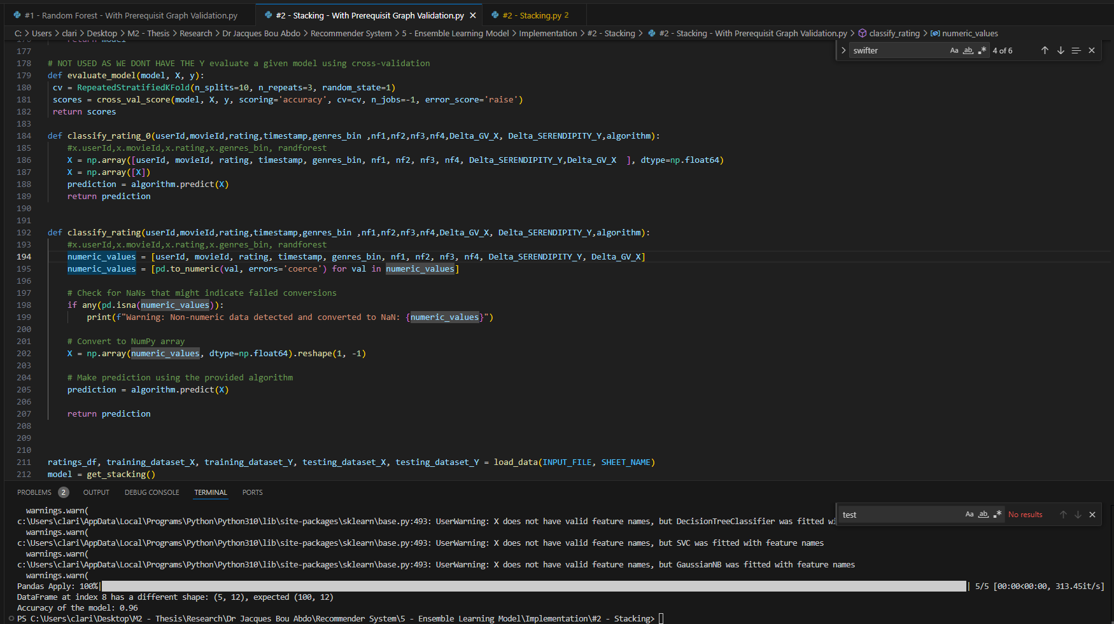

Same as nf1 😊

In my opinion yaret fina naamol baed test